Task 1
#include <iostream>
#include <cstring>

using namespace std;

int main() {
int n, m;
cin >> n >> m;

string symbols[10];
for (int i = 0; i < m; i++) {
cin >> symbols[i];
}

int trans[50][10];

for (int i = 0; i < n * m; i++) {
int from, to;
string sym;
cin >> from >> sym >> to;

for (int j = 0; j < m; j++) {
if (symbols[j] == sym) {
trans[from][j] = to;
}
}
}

int start;
cin >> start;

int f;
cin >> f;
int finalStates[50] = {0};
for (int i = 0; i < f; i++) {
int x;
cin >> x;
finalStates[x] = 1;
}

int group[50];
for (int i = 0; i < n; i++) {
if (finalStates[i]) {
group[i] = 1;
} else {
group[i] = 0;
}
}

int changed = 1;
while (changed) {
changed = 0;

int newGroup[50];
int groupCount = 0;

for (int i = 0; i < n; i++) {
int found = -1;
for (int j = 0; j < i; j++) {
if (group[i] == group[j]) {
int same = 1;

for (int k = 0; k < m; k++) {
if (group[trans[i][k]] != group[trans[j][k]]) {
same = 0;
break;
}
}

if (same) {
found = newGroup[j];
break;
}
}
}

if (found == -1) {
newGroup[i] = groupCount++;
} else {
newGroup[i] = found;
}
}

for (int i = 0; i < n; i++) {
if (group[i] != newGroup[i]) {
changed = 1;
break;
}
}

for (int i = 0; i < n; i++) {
group[i] = newGroup[i];
}
}

cout << "Equivalent Groups:" << endl;

int printed[50] = {0};
for (int i = 0; i < n; i++) {
if (!printed[i]) {
cout << "{";
cout << i;
printed[i] = 1;

for (int j = i + 1; j < n; j++) {
if (group[i] == group[j]) {
cout << "," << j;
printed[j] = 1;
}
}
cout << "}" << endl;
}
}

cout << "Start State = {";
for (int i = 0; i < n; i++) {
if (group[i] == group[start]) {
cout << i << ",";
}
}
cout << "\b}" << endl;

cout << "Final States:" << endl;

int printedGroup[50] = {0};

for (int i = 0; i < n; i++) {
if (finalStates[i] && !printedGroup[group[i]]) {
cout << "{";

for (int j = 0; j < n; j++) {
if (group[j] == group[i]) {
cout << j << ",";
}
}

cout << "\b}" << endl;
printedGroup[group[i]] = 1;
}
}

cout << "Minimized DFA Transition Table:" << endl;

for (int i = 0; i < n; i++) {
int isRep = 1;

for (int j = 0; j < i; j++) {
if (group[i] == group[j]) {
isRep = 0;
break;
}
}

if (!isRep) {
continue;
}

for (int k = 0; k < m; k++) {
cout << "{";

for (int j = 0; j < n; j++) {
if (group[j] == group[i]) {
cout << j << ",";
}
}

cout << "\b} --" << symbols[k] << "--> {";

int next = trans[i][k];

for (int j = 0; j < n; j++) {
if (group[j] == group[next]) {
cout << j << ",";
}
}

cout << "\b}" << endl;
}
}

return 0;
}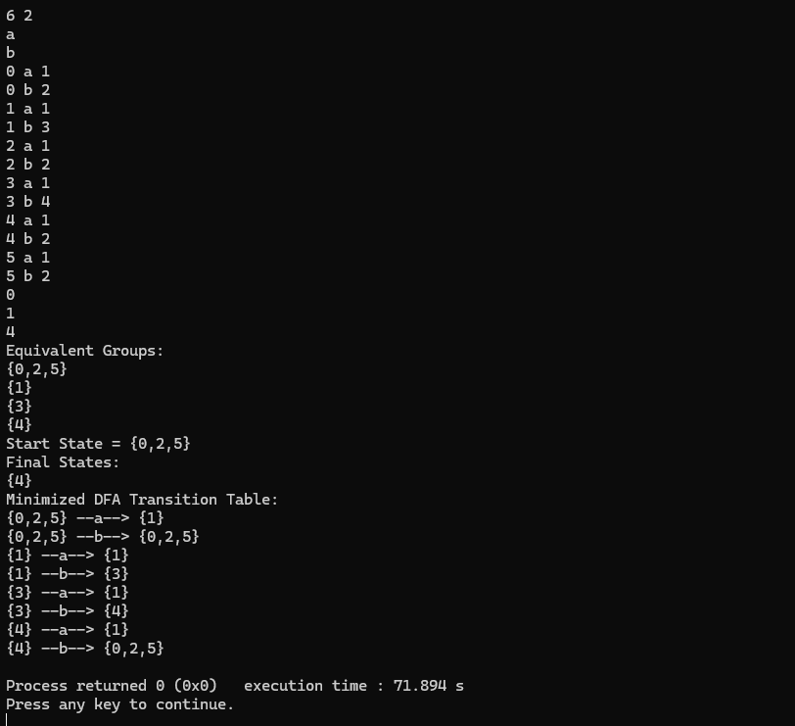

Task 2
#include <iostream>
#include <cstring>

using namespace std;

int main() {
int n, m;
cin >> n >> m;

string symbols[10];
for (int i = 0; i < m; i++) {
cin >> symbols[i];
}

int trans[50][10];

for (int i = 0; i < n * m; i++) {
int from, to;
string sym;
cin >> from >> sym >> to;

for (int j = 0; j < m; j++) {
if (symbols[j] == sym) {
trans[from][j] = to;
}
}
}

int start;
cin >> start;

int f;
cin >> f;

int finalStates[50] = {0};

for (int i = 0; i < f; i++) {
int x;
cin >> x;
finalStates[x] = 1;
}

int group[50];

for (int i = 0; i < n; i++) {
if (finalStates[i]) {
group[i] = 1;
} else {
group[i] = 0;
}
}

int changed = 1;

while (changed) {
changed = 0;
int newGroup[50];
int groupCount = 0;

for (int i = 0; i < n; i++) {
int found = -1;

for (int j = 0; j < i; j++) {
if (group[i] == group[j]) {
int same = 1;

for (int k = 0; k < m; k++) {
if (group[trans[i][k]] != group[trans[j][k]]) {
same = 0;
break;
}
}

if (same) {
found = newGroup[j];
break;
}
}
}

if (found == -1) {
newGroup[i] = groupCount++;
} else {
newGroup[i] = found;
}
}

for (int i = 0; i < n; i++) {
if (group[i] != newGroup[i]) {
changed = 1;
break;
}
}

for (int i = 0; i < n; i++) {
group[i] = newGroup[i];
}
}

cout << "Equivalent Groups:" << endl;

int printed[50] = {0};

for (int i = 0; i < n; i++) {
if (!printed[i]) {
cout << "{";
cout << i;
printed[i] = 1;

for (int j = i + 1; j < n; j++) {
if (group[i] == group[j]) {
cout << "," << j;
printed[j] = 1;
}
}
cout << "}" << endl;
}
}

int startGroup = group[start];

cout << "Start State = {";
for (int i = 0; i < n; i++) {
if (group[i] == startGroup) {
cout << i << ",";
}
}
cout << "\b}" << endl;

cout << "Final States:" << endl;

int printedGroup[50] = {0};
int isFinalGroup[50] = {0};

for (int i = 0; i < n; i++) {
if (finalStates[i]) {
isFinalGroup[group[i]] = 1;
}
}

for (int i = 0; i < n; i++) {
if (finalStates[i] && !printedGroup[group[i]]) {
cout << "{";

for (int j = 0; j < n; j++) {
if (group[j] == group[i]) {
cout << j << ",";
}
}

cout << "\b}" << endl;
printedGroup[group[i]] = 1;
}
}

cout << "Minimized DFA Transition Table:" << endl;

for (int i = 0; i < n; i++) {
int isRep = 1;

for (int j = 0; j < i; j++) {
if (group[i] == group[j]) {
isRep = 0;
break;
}
}

if (!isRep) {
continue;
}

for (int k = 0; k < m; k++) {
cout << "{";
for (int j = 0; j < n; j++) {
if (group[j] == group[i]) {
cout << j << ",";
}
}
cout << "\b} --" << symbols[k] << "--> {";

int next = trans[i][k];

for (int j = 0; j < n; j++) {
if (group[j] == group[next]) {
cout << j << ",";
}
}
cout << "\b}" << endl;
}
}

int q;
cin >> q;

while (q--) {
string str;
cin >> str;

cout << "String: " << str << endl;
cout << "Path: ";

int currentGroup = startGroup;

cout << "{";
for (int i = 0; i < n; i++) {
if (group[i] == currentGroup) {
cout << i << ",";
}
}
cout << "\b}";

for (int i = 0; i < str.length(); i++) {
char ch = str[i];

int symbolIndex = -1;

for (int j = 0; j < m; j++) {
if (symbols[j][0] == ch) {
symbolIndex = j;
break;
}
}

int rep = -1;
for (int j = 0; j < n; j++) {
if (group[j] == currentGroup) {
rep = j;
break;
}
}

int nextState = trans[rep][symbolIndex];
currentGroup = group[nextState];

cout << " -> {";
for (int j = 0; j < n; j++) {
if (group[j] == currentGroup) {
cout << j << ",";
}
}
cout << "\b}";
}

cout << endl;

if (isFinalGroup[currentGroup]) {
cout << "Accepted" << endl;
} else {
cout << "Rejected" << endl;
}
}

return 0;
}
